Apply filters to SQL queries

Project description
My job is to make system of organizations more secure. It is my job to ensure the system is safe, investigate all potential security issues, and update employee computers as needed. The following steps provide examples of how I used SQL with filters to perform security-related tasks. I needed to obtain specific information about employees, their machines, and the departments they belong to from the database. Our team needed data to investigate potential security issues and to update computers. I was responsible for filtering the required information from the database.

Retrieve after hours failed login attempts
I was investigating failed login attempts that were made after business hours. I needed to retrieve this information from the login activity. I dentified all unsuccessful attempts after 18:00.
I used select * command to get informations from all columns.
Then I used from log_in_attempts command to get those informations from ‘log_in_attempts’ table
In last line I did set up filter to get logins only after 18:00 and unsuccessful logins marked as ‘0’ by where login_time > '18:00' and success = 0; command. Command and has been used as there was query with multiple conditions needed.

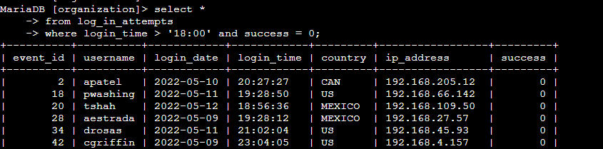

Retrieve login attempts on specific dates
Then I was investigating a suspicious event that occurred on '2022-05-09'. I needed to retrieve all login attempts that occurred on this day and the day before ('2022-05-08')
I used select * command to get informations from all columns.
Then I used from log_in_attempts command to get those informations from ‘log_in_attempts’ table
In last line I did set up filter to get logins from dates i needed by where login_date = '2022-05-09' or login_date = '2022-05-08';
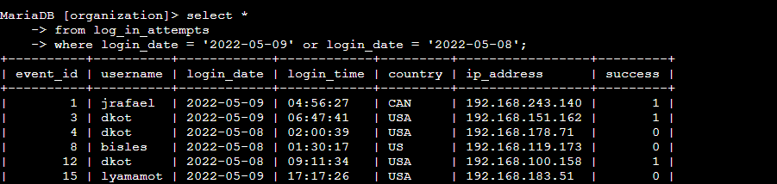

Retrieve login attempts outside of Mexico
Then I needed to investigate logins that did not originate in Mexico, and you need to find this information.
I used select * command to get informations from all columns.
Then I used from log_in_attempts command to get those informations from ‘log_in_attempts’ table
In last line I did set up filter to get logins that was not from Mexico by where not country like 'MEX%'; command. As ‘Mexico’ was marked by either ‘MEX’ and ‘MEXICO’ I used command like and wildcard ‘%’ to get both markings.
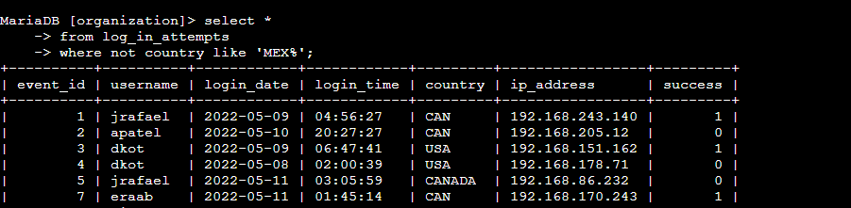

Retrieve employees in Marketing
Team is updating employee machines, and I needed to obtain the information about employees in the 'Marketing' department who are located in all offices in the East building marked as ‘East-xxx’
I used select * command to get informations from all columns.
Then I used employees command to get those informations from ‘employees’ table
In last line I did set up filter to get only employees from ‘Marketing’ department who was located in East building by using where department = 'Marketing' and office like 'East%'; command
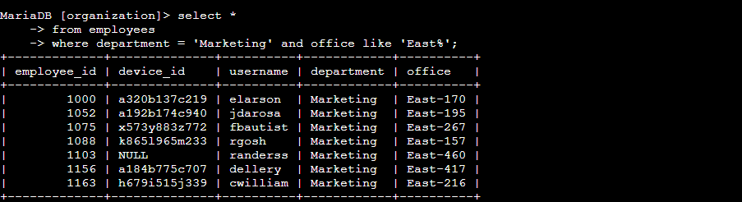

Retrieve employees in Finance or Sales
Now, our team needed to perform a different update to the computers of all employees in the Finance or the Sales department, So I needed to locate information on these employees.
I used select * command to get informations from all columns.
Then I used employees command to get those informations from ‘employees’ table
In last line I did set up filter to get only employees from ‘Finance’ and ‘Sales’ departments by using where department = 'finance' or department = 'Sales'; command

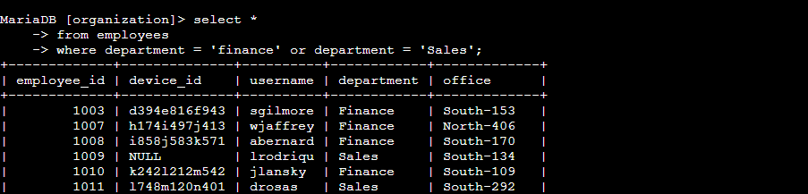

Retrieve all employees not in IT
Our team needed to make one more update. This update was already made to employee computers in the Information Technology department. The team needed information about employees who are not in that department.
I used select * command to get informations from all columns.
Then I used employees command to get those informations from ‘employees’ table
In last line I did set up filter to get all employees apart from employees from ‘IT’ departments by using where not department = 'Information Technology'; command

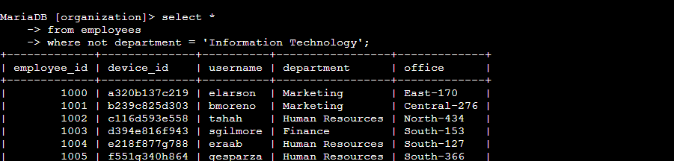

Summary
I applied filters to SQL queries to get specific information on login attempts and employee machines. I used two different tables, log_in_attempts and employees. I used the AND, OR, and NOT operators to filter for the specific information needed for each task. I also used LIKE and the percentage sign (%) wildcard to filter for patterns.

